Laboratory Animal Resources Guidelines

Guidelines for Genotyping Laboratory Mice and Rats

- Purpose- Researchers must consider all sources of DNA to perform genotype analysis, including alternatives to invasive procedures such as tail biopsy. As with any procedure, the specific method of tissue collection must be detailed in the approved IACUC protocol. This document serves to describe examples of procedures that could be used to safely and appropriately collect samples to genotype rodents used in laboratory animal research at Indiana University Bloomington.

- Definitions:
Genotyping- The process through which an animal’s genetic make-up is determined using a tissue sample.
Identification- The process of uniquely marking an animal so it can be differentiated from other animals within a group.

- Responsibility:
The laboratory staff is responsible for implementing the IACUC approved genotyping methods with oversight and assistance from LAR staff, as needed.
The Principal Investigator (PI) is responsible for ensuring that all methods of animal genetic sampling are explicitly listed and approved by the Institutional Animal Care and Use Committee (IACUC) in the applicable animal use protocol and that laboratory staff are trained to perform these procedures.

- Acceptable Sources of Animal Genetic Material for Genotyping

Determining the genotype in a rodent litter that has been genetically engineered is critically important. The genotype is most often determined by analysis of DNA extracted from tissues of young rodents. Analysis by the Polymerase Chain Reaction (PCR) requires the least amount of DNA. Small amounts of DNA can be obtained from ear punches, tail biopsies, or various non-invasive alternatives. Larger amounts of DNA required for determination of genotype by Southern Blot are usually obtained from tail biopsies. Depending on the requirements of the study, investigators are urged to consider noninvasive alternatives such as hair, fecal or oral samples.

- Ear Punching/Notching- application of a specific combination of small hole punches or notches to the outside edges of a rodent’s ear (see Fig. 1a).
- Ear notching/punching can provide tissue for genotyping and as a means of permanent identification.
- The procedure should be performed after 14 days of age which is when the pinnae (ears) are generally large enough to punch/notch.
- Ear punch or notching instruments are disinfected with alcohol or a hot bead sterilizer between animals to avoid sample contamination.
- Ear punches should be no larger than 2 mm.
- Mouse Ear-punching (see Figure 1a)
- The mouse is restrained by the scruff (see Fig. 1b) and an ear puncher (see Fig. 1c) is used to make holes and/or notches in the ears following an identification chart.
- A small amount of bleeding is expected and can be controlled by gentle, constant pressure. Animals should be checked several hours post-procedure to ensure proper hemostasis.

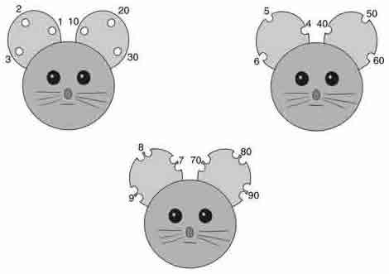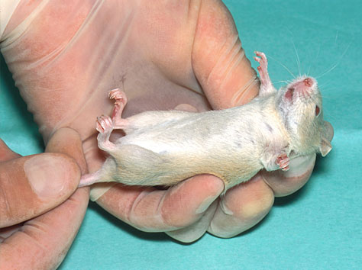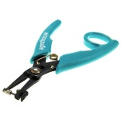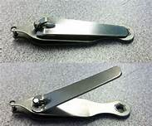
Fig. 1a Mouse ear punch Fig. 1b Mouse restraint Fig. 1c Mouse ear punches

- Rat Ear-punching (see Fig. 2)
- Firmly restrain the animal. Restraint methods that can be used include:
- The two-handed technique: first place the rat on your arm, holding the base of the tail with your hand. Hug the rat at the shoulders and push in gently at the elbows to cross the front legs. Still maintaining your hold at the base of the tail, stretch out the abdomen. Grasp the rear legs and immobilize (see Fig. 2a).
- If more restraint is needed, the rat may need to be scruffed by grasping the loose skin behind the neck.
- A restraining device, which allows access to the head while still immobilizing the animal, may also be used. An ear puncher is then used to make holes and/or notches in the ears (a second person will be needed to do this).
- Ear puncher (see Fig. 2b) is used to make holes and/or notches in the ears following an identification chart. (Fig. 2c)
- Hemostasis of the ear notch/punch site can be achieved by compression.

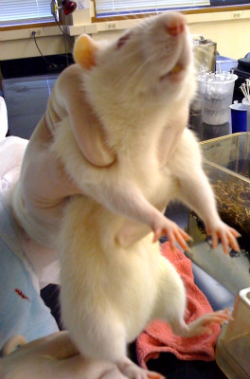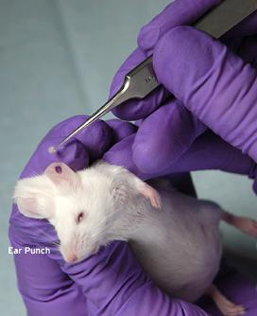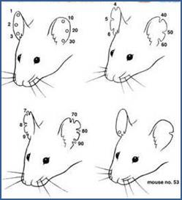

Fig. 2a Rat restraint Fig. 2b Collecting punch Fig. 2c Rat ear punches

- Tail Biopsy
- The tail clip or biopsy procedure is momentary, but involves bone or cartilage, blood vessels, nervous tissue and skin. There is potential for pain from this procedure. Analgesics may be used if prolonged pain is anticipated. The smallest possible section of tail is removed and adequate hemostasis is achieved. Current literature shows that 5mm is sufficient tissue to extract DNA for genotyping procedures. No more than 5 mm can be removed at one time without first securing IACUC approval.
- In the mouse, the distal tail is completely ossified and innervated between 17-21 days of age. Thus, tail sampling is recommended in mice and rats less than 3 weeks of age to avoid undue stress and discomfort to the animals. The optimum age at which to perform biopsy is between 12-17 days, before the distal tail completely ossifies.
- Tail snips in animals < 17 days of age, 2-5 mm tail tip sample is obtained without the need for anesthetics or analgesics.
- Tail snips in animals 18-21 days of age, 2-5 mm tail tip sample is obtained with local and systemic analgesics recommended. For local analgesia, use Bupivacaine 0.75% and immerse the tail in the bupivacaine for 10 sec. after biopsy. Systemic analgesic agents such as Meloxicam or Buprenorphine are encouraged but not required.
- Tail snips in animals > 21 days old, 2-5 mm tail tip sample is obtained using the required local analgesic bupivacaine 0.75% and immersing the tail in the bupivacaine for 10 sec. after biopsy. Tail biopsy must be performed with general anesthesia (i.e. Isoflurane) followed by analgesic such as Meloxicam or Buprenorphine (see LAR Guidelines for Anesthesia and Analgesia in Mice or Rats for recommendations). Any situation where general anesthesia cannot be used for tail biopsies in mice or rats over 21 days of age must be scientifically justified in the animal use application and approved by IACUC.
- If multiple tail biopsies must be performed because of inconclusive PCR or lost samples, local analgesia with bupivacaine 0.75% is recommended as long as 2-5 mm tail sample is taken and the animal is <21 days old. If animals are >21 days, 2-5 mm tail tip sample is obtained while the animal is under isoflurane anesthesia using bupivacaine as a local analgesic and Meloxicam or Buprenorphine as systemic analgesics.
- Mouse Procedure:
- Gently but securely restrain the rodent. (Fig. 3a)
- Swab the tail with alcohol (povidone iodine or chlorhexidine may interfere with the DNA identification tests).
- Sterile tools for this procedure are recommended. Disposable scalpel blades or razor blades can be used as a sterile method as long as a new, sterile blade is used for each mouse or rat. Alternatively, scissors can be sterilized using a hot bead sterilizer between animals. Reuse of a scalpel blade or not sterilizing scissors can lead to contamination of samples and invalidation of results.
- Snip the skin sample that is < 5 mm and place in sample container with label. (Fig. 3b)
- Hemostasis of the tail biopsy site can be achieved using compression of the tail, application of silver nitrate or styptic pencils or tissue adhesives (e.g. Nexaband®). (Fig. 3c)
- Observe rodent for bleeding or abnormal behavior; check daily to ensure tip is healing.
- If the mouse or rat is anesthetized using general anesthesia, the animal is then recovered individually in a clean cage after the biopsy is completed. The mouse or rat must be fully ambulatory before it is returned to the original cage or co-housed with other rodents.
- ALL animals (regardless of age) must be monitored for 5 minutes after returning to their cage for any signs of bleeding from the site.

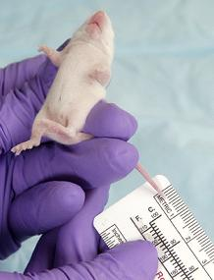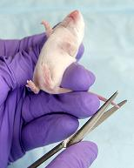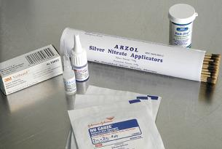
Fig. 3a Measure tail Fig. 3b Cut tail Fig. 3c Hemostasis materials

- Toe Amputation/Toe Clipping
  - Toetip clipping (toe amputation) involves the removal of the toe at the most distal joint. According to the Guide for the Care and Use of Laboratory Animals (Guide), “toe clipping should be used only when no other individual identification method is feasible. It may be the preferred method for neonatal mice up to 7 days of age as it appears to have few adverse effects on behavior and well-being at this age…especially if toe clipping and genotyping can be combined”.
  - Toe clipping in rodents greater than 7 days old is a stressful procedure that should only be performed if no other identification and genotyping options are feasible. If toe clipping is requested, it should be used for genotyping and identification purposes.
  - Conditions for Approval: Toe clipping will only be permitted when the following conditions are met:
      - The Principal Investigator (PI) provides a scientific justification with documentation to the IACUC explaining why each of the alternative identification methods listed in the Policy for Identification of Mice and Rats are not feasible. Cost alone is NOT considered an adequate justification.
      - Once the procedure is approved, all laboratory personnel designated to perform the procedure must undergo training and/or demonstrate proficiency to the PI or LAR trainer.
      - Toe clipping can only be performed on animals thirteen (13) days of age or younger. Neonatal mice 5-7 days of age may be toe clipped for genotyping and identification purposes without the use of anesthesia.
      - Mice 8-13 days of age at the time of the procedure may be toe clipped ONLY if the toe tissue is also used for genetic analysis. This would be considered a refinement by making it unnecessary to perform tail biopsies for tissue sampling. Topical anesthesia is required and can be accomplished by immersing the toe in bupivacaine 0.75% for 30 sec. immediately after biopsy.
      - The numbering system should be designed to minimize the total number of toes clipped per animal. Similarly, a given foot should have as few toes clipped as possible.
      - The following must be followed:
- No more than two toes are amputated per foot, and two feet per animal may be clipped.
- Avoid clipping toes on forepaws, if possible.
- DO NOT clip the 1st digit (i.e. thumb) on either forepaw.
- Remove the 3rd phalanx (i.e. toe-nail bearing, last bone of digit); cutting the very distal portion of the 2nd phalanx to remove the complete nail bed.
      - If animal genotyping is required, the tissue yielded from toe clipping is used. A second method of tissue collection (e.g. tail biopsy) will only be accepted if tissue is lost or a second genotyping is required.
  - Appropriate Method for Toe Clipping
      - Instrument preparation- instrument must be disinfected between animals. Instruments should be sharpened regularly to ensure minimization of tissue injury.
      - Skin preparation- Gross debris, if present, will be cleaned from the foot. Alcohol may be used to wipe down the foot and digits prior to the amputation.
      - Neonatal mice are placed on a soft padding of some kind (e.g. blue diaper pad, towel). Using gentle pressure, restrain the mouse and extend the leg. Rodents are restrained only by hand for this procedure, and not by a restraint device. Taking care to hold a mouse properly is the most important aspect of ensuring its comfort and safety.
      - With a sharp pair of dissecting scissors or scalpel, remove the toe at the most distal joint and into the distal tip of the 2nd phalanx.
      - After removing the digit, apply a piece of gauze to the distal portion of the digit with finger pressure to ensure hemostasis. ALL animals (regardless of age) must be monitored for 5 minutes after returning to their cage for any signs of bleeding from the site.
      - Place the pups that have been identified into a new cage to distinguish them from their littermates. When all of the pups have been identified, return the pups to their mother’s cage.
  - Day 5-7 and 8-13: No more than 2 toes per foot should be removed, with a maximum of 4 total clipped toes per animal.
N=nail
P3= phalanx 3
P2= phalanx 2
P1= phalanx 1
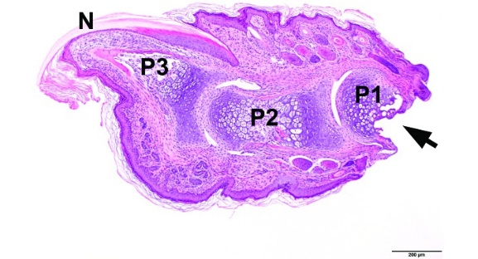
Line indicates where cut of digit should occur
- Other
  - Blood- can be used for genotyping but not identification; noninvasive.
  - Hair follicles- noninvasive; used for genotyping, high risk of contamination
  - Colonic and Rectal cells- samples rectal swab or scrape or fecal pellets; genotyping but not identification; feces collected within 24 hours.
  - Cells from the Oral Mucosa- oral cavity scraped or swabbed; low amount of DNA obtained.

Table 1. Methods for Genotyping Rodents
Method | Age | Anesthesia Requirements | Additional Information
Ear-punching | 14 days or older | No anesthesia is required when performed by trained personnel | - Punch devices should be disinfected between animals  - Tissue can also be used for genotyping  - Punched tissue may re-seal; must be rechecked periodically and punching may need to be repeated  - after 2 weeks of age
Tail Biopsy | 12-17 days old | No anesthesia is required when performed by trained personnel | - 2-5 mm tail can be biopsied  - Restrain animal  - Swab tail with alcohol  - Use sterile scalpel blade, razor or sharp scissors (clean with alcohol between or hot bead sterilizer)  - Hemostasis of tail by compression  - Monitor for at least 5 min. after biopsy
 | 18-21 days old | Local and systemic analgesia is recommended but not required
 | >21 days old | General anesthesia (isoflurane) required  Local analgesic Bupivicaine 10 sec. required  Systemic analgesics (Meloxicam or Buprenorphine) required
Toe-clipping | Rats from 5-7 days old  Mice from 5-13 days old | No anesthesia is required P 5-7 when performed by trained personnel  Topical/local anesthesia is required for P 8-13 animals | - Equipment and site should be disinfected prior to clipping to minimize risk of infection  - Ensure only distal bone (P3) and nail bed are removed including distal portion of P2  - May impair grip strength  - Tissue can also be used for genotyping  - Day 5-7: no more than 2 toes/foot (up to 4 toes total) can be removed  - Day 8-13: No more than 2 toes total can be removed.
Non-permanent marking | Any age | Only for dying | - Inexpensive but not permanent  - Use nontoxic dyes or markers

References

Bonaparte (Convenor) D, Cinelli P, Douni E, Herault Y, Maas A, Pakarinen P, Poutanen M, Lafuente MS, Scavizzi F. FELASA guidelines for the refinement of methods for genotyping genetically-modified rodents: A report of the Federation of European Laboratory Animal Science Associations Working Group. Lab Anim. 2013; 47(3): 134-145.

Braden GC, Brice AK, Hankenson FC. Adverse Effects of Vapocoolant and Topical Anesthesia for Tail Biopsy of Preweanling Mice. JAALAS, May 2015; 54(3): 291-298.

Castelhano-Carlos MJ, et. al. 2010. Identification methods in newborn C57BL/6 mice: a developmental and behavioral evaluation. Lab Anim. 1-16.

Dahlborn K, Bugnon P, Nevalanen R, Raspa M, Verbost P, Spangenberg E. Report of the Federation of European Laboratory Animal Science Associations Working Grou on animal identification. Lab Anim. 2013; 47: 2-11.

Diesch TJ, Mellor DJ, Johnson CB, Lentle. 2009. Electoencephalographic responses to tail clamping in anesthetized rat pups. Lab Anim 43(3): 224-31.

Garrels W, Cleve N, Niemann H, Kues WA. Rapid non-invasive genotyping of reporter transgenic mammals. Biotechniques. May 2012, p 1-4.

Guide for the Care and Use of Laboratory Animals, National Research Council, 8th Edition, pp 120-123.

Hankenson FC, et al. 2008. Evaluation of tail biopsy collection in laboratory mice (Mus musculus): vertebral ossification, DNA quantity, and acute behavioral responses. JAALAS; 47(6): 10-18.

Hankenson FC, Braden-Weiss GC, Blendy JA. Behavioral and Activity Assessment of Laboratory Mice (Mus musculus) After Tail Biopsy Under Isoflurane Anesthesia. JAALAS, Sept. 2011; 50(5): 686-694.

Jones CP, Carver S, Kendall LV. Evaluation of Common Anesthetic and Analgesic Techniques for Tail Biopsy in Mice. JAALAS; Nov. 2012; 51(6): 808-814.

NIH “Guidelines for Toe Clipping of Rodents” [Internet]. May 2010. Available at http://oacu.od.nih.gov/ARAC/

NIH “Guidelines of the Genotyping of Mice and Rats”. May 2010; http://oacu.od.nih.gov/ARAC/documents/Rodent_Genotyping.pdf

Norecopa “Supplementary Statement on Toe Clipping in Rodents”. March 19, 2010. http://www.norecopa.no/norecopoa/vedlegg/Supplementary-statement-190310.pdf.

Paluch LR, Lieggie CC, Dumont M, Monette S, Riedel ER, Lipman NS. Developmental and Behavioral Effects of Toe clipping on Neonatal and Preweanling Mice with and without Vapocoolant Anesthesia. JAALAS. 2014 Mar; 53(2): 132-140.

Philbert RA, Zadorozhnyaya I, Beach SRH, Brody GH. A Comparison of the Genotyping Results Using DNA Obtained from Blood and Saliva. Psychiatr Genet. 2008 December; 18(6): 275-281.

Public Health Service Policy on Humane Care and Use of Laboratory Animals, 2002. Health Research Extension Act of 1985, Public Law 99-158, Animals in Research, Principle V. Procedures with animals that may cause more than momentary or slight pain or distress should be performed with appropriate sedation, analgesia, or anesthesia. Surgical or other painful procedures should not be performed on unanesthetized animals paralyzed by chemical agents.

Schaefer DC, et al. 2010. Analysis of physiological and behavioral parameters in mice after toe clipping as newborns. Lab Anim. 44:7-13.

Symonds EL, Fenech M. A method for non-invasive genotyping of APCmin/+ mice using fecal samples. Biol Proced Online. 2012. 14: 1, Jan. 30, 2012.

University of Tennessee Mouse and Rat Toe Clipping. https://www.uthsc.edu/research/compliance/iacuc/documents/mouse-and-rat-toe-clipping.pdf
University of Pennsylvania IACUC Guideline Rodent Identification. http://www.upenn.edu/regulatoryaffairs/Documents/iacuc/guidelines/iacucguideline-rodentidentification.pdf

