Laboratory Animal Resources Guidelines

Guidelines for Use of Hazards in the Animal Facilities

- Purpose
Hazardous materials occasionally need to be used in the course of conducting animal experiments. This policy enacts those provisions of the following federal and state requirements pertaining to the use of hazardous materials in research, teaching, and testing activities that involve vertebrate animals.
- Public Health Service Policy on Humane Care and Use of Laboratory Animals, published by the Office of Lab Animal Welfare, NIH.
- Occupational Health and Safety in the Care and Use of Research Animals, published by the National Academy of Sciences, 1997.
- Guide for the Care and Use of Laboratory Animals, published by National Research Council, 2011
- Biosafety in Microbiological and Biomedical Laboratories 6th Edition, published by the Centers for Disease Control and Prevention and the National Institutes for Health, 2020.
- NIH Guidelines for Research Involving Recombinant or Synthetic Nucleic Acid Molecules, 2019 (NIH Guidelines)
- Federal Select Agent Regulations (7CFR331, 9CFR121, and 42CRF73)
- Indiana University Laboratory Safety and Chemical Hygiene Plan https://protect.iu.edu/doc/environmental-health/IU_Laboratory_Safety_and_Chemical_Hygiene_Plan.pdf
- Code of Federal Regulations, PART 20—Standards For Protection Against Radiation Title 10, Part 20
This guideline is applicable to all vertebrate animal activities conducted under the auspices of the University and applies to all Bloomington campus locations including satellite facilities.
- Definitions:
    - Hazardous Materials

Hazardous materials are those materials that constitute a hazard to humans or the environment. The Guidelines for Use of Hazards in the Animal Facilities applies to the specific hazardous materials listed below when used in conjunction with vertebrate animals:
- Biological agents requiring handling conditions above Biosafety Level 1 (BSL-1).
- Biological agents requiring animals to be housed in conditions above Animal Biosafety Level 1 (ABSL-1).
- Biological specimens (e.g., saliva, blood, and urine) collected from humans or non-human primates.
- Biological toxins (e.g., Botulinum toxin including cosmetic BOTOX).
- All activities, regardless of Biosafety Level, involving recombinant or synthetic nucleic acid molecule technology (rDNA techniques).
- HHS and USDA Select Agents and Toxins, as defined in Federal Regulations 7 CFR 331, 9 CFR 121, and 42 CFR 73. The current list is available at https://www.selectagents.gov.
- Activities involving any radiation producing equipment or materials including ionizing, non-ionizing, x-rays, and lasers.
- Chemicals designated as particularly hazardous agents including hazardous drugs, carcinogens, reproductive hazards, nanoparticles, or toxic chemicals, as well as materials that may have serious impact on the environment during release or disposal that are used in conjunction with animals.
    - Biosafety Levels (BSL)- standard microbiological practices, special practices, safety equipment, and laboratory facilities for activities involving infectious microorganisms, toxins and laboratory animals.
      - Biosafety Level 1 (BSL-1)- suitable for work involving well-characterized agents not known to consistently cause disease in immunocompetent adult humans and that present minimal potential hazard to laboratory personnel and the environment.
      - Biosafety Level 2 (BSL-2)- suitable for work with agents associated with human disease and pose moderate hazards to personnel and the environment.
      - Biosafety Level 3 (BSL-3)- suitable for work with indigenous or exotic agents that may cause serious or potentially lethal disease through the inhalation route of exposure.
      - Biosafety Level 4 (BSL-4)- required for work with dangerous and exotic agents that pose a high individual risk of aerosol-transmitted laboratory infections and life-threatening diseases that are frequently fatal, agents for which there are no vaccines or treatments, or work with a related agent with unknown risk of transmission.

    - Animal Biosafety Levels (ABSL)
      - Animal Biosafety Level 1 (ABSL-1)- suitable for work involving well-characterized agents that are not known to consistently cause disease in immunocompetent adult humans and present minimal potential hazard to personnel and environment.
      - Animal Biosafety Level 2 (ABSL-2)- suitable for work involving laboratory animals infected with agents associated with human disease and posing a moderate hazard to personnel and the environment.
      - Animal Biosafety Level 3 (ABSL-3)- suitable for work with laboratory animals infected with indigenous or exotic agents, agents that present a potential for aerosol transmission, and agents causing serious or potentially lethal disease.
      - Animal Biosafety Level 4 (ABSL-4)- required for work with animals infected with dangerous and exotic agents that pose a high individual risk of aerosol-transmitted laboratory infections and life-threatening diseases that are frequently fatal, agents for which there are no vaccines or treatments, or work with a related agent with unknown risk of transmission.

D. Personal Protective Equipment (PPE)

Personal Protective Equipment (PPE) is a device or garment worn by the worker to protect against hazards. Examples of PPE include such items as gloves, foot and eye protection, face shields, protective hearing devices (earplugs, muffs), hard hats, respirators, and full body suits.

- Responsibility:
- The IACUC along with the IBC delegate authority to EHS and LAR to enforce the provisions of these guidelines. Refer to the IBC or IACUC to implement sanctions if infractions should occur. The delegation includes but is not limited to:
    - Monitoring activities covered by these guidelines.
    - Enforcing the implementation of the defined requirements.
    - Implementing sanctions and/or suspensions.
- The laboratory staff are responsible for implementing the hazard guidelines in the animal facility.
- The Principal Investigator (PI) is responsible for ensuring that all research staff are appropriately trained in identifying hazards, understanding how to handle hazardous material and how to appropriately dispose of hazardous material.
- Procedures- Activities involving hazardous materials used in conjunction with vertebrate animals must be in accordance with the approval of the relevant University oversight committees, where applicable, and in accordance with Environment, Health & Safety (EHS)-defined engineering control practices, using the appropriate Personal Protective Equipment (PPE), and following all applicable safety SOPs and policies.
- Biohazards: Before the IACUC approves use of biohazards in animals, approval by the Institutional Biosafety Committee (IBC) is necessary. Animal users provide the required information needed to conduct the risk assessment (e.g., name of the hazard, nature of hazard, route of administration and dose) through an IACUC protocol submission and, where applicable, to the IBC (only rDNA and ABSL2 and higher agents are required to have an IBC protocol). The review and approval process of the IACUC and IBC includes EHS staff who specialize in biosafety and who identify appropriate control measures for the work.
- Chemical hazards: Before the IACUC approves the use of chemicals in animals, EHS identifies particularly hazardous agents (PHA) by their LD50, mechanism of action and/or metabolites, as well as their environmental impact and identifies appropriate control measures. Information needed to conduct the risk assessment (e.g., chemical or compound name, dose, and route of administration) is provided to the IACUC and EHS directly in the animal care and use protocol. All chemicals used with animals are included in every protocol and a risk assessment performed on every compound so that those that should be treated as hazards are identified.
- Environmental hazards: Materials that, if released into the environment, have the potential of causing harm or damage to natural plants or animals in their home environment.
- Radioisotopes: Before the IACUC approves use of radioisotopes in animals, approval by the Radiation Policy Committee (RPC) is necessary. Animal users provide the required information needed to conduct the risk assessment (e.g., nature of hazard, dose, and route of administration) through a submission to the RPC. The review and approval process of the RPC includes EHS staff who specialize in radiation safety and who identify appropriate control measures for the work.
- Procedures
  - Principal Investigators are to identify biological hazards and chemicals/compounds used in conjunction with experiments performed using animals in their IACUC and IBC protocols.
  - The IBC reviews the IBC protocol (only rDNA and ABSL2 and higher agents are required to have an IBC protocol) and evaluates the requested use of biological hazards in the protocol. Issues are discussed between the investigator, IBC members and experts in EHS until all issues have been resolved. IBC approves the IBC protocol.
  - The IACUC reviews the animal protocol and evaluates the requested use of biological, chemical, environmental and radiation hazards in the protocol. Issues are discussed between the investigator, IACUC members, and experts in EHS until all issues have been resolved. IACUC approves the IACUC protocol.
  - EHS experts initiate creation of a hazard sign when necessary to be posted on the animal room door in the animal facilities through collaboration with LAR in a shared folder. Information is exchanged and a hazard sign generated once all issues are resolved. This form (see Appendix 1) is to be posted on the door of the animal housing room where hazards are to be used.
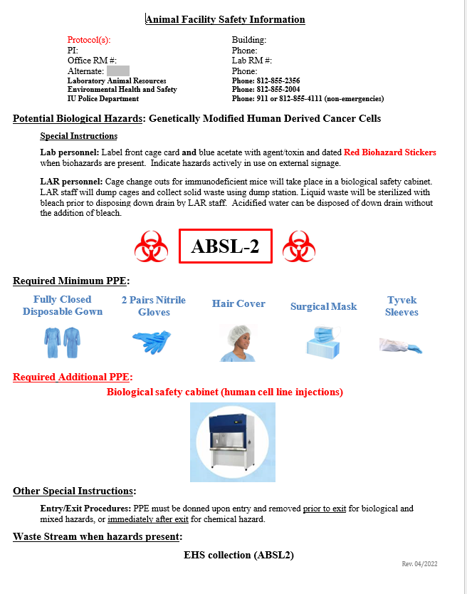

5. Principal Investigators are to train their staff on this policy and the specific hazards being used in the animal facilities and how to appropriately label materials that are hazardous in the animal facilities.
6. As experiments are assigned to research personnel to be conducted by bringing hazards into the animal facility, research staff should become familiar with the hazard and the steps to identify use of the hazard in the animal facilities.
7. All hazardous materials intended for animal administration or exposure are to be prepared in the research lab following EHS recommendations. Materials to be dosed in a small aliquot are brought in closed systems to the animal facility using appropriately labeled secondary containers marked with the type of hazard present.
8. Before dosing animals, research staff should check the Animal Facility Safety Information /Hazard sign to make sure that the hazardous material is listed on this form with instructions on PPE to wear and disposal instructions (Appendix 1). Next, the hazardous material to be dosed should be marked under the appropriate category on the orange Hazard Identification Sheet (see Appendix 2) door sign with dates that the agent will be present in the room. This sign should list the specific hazard ONLY when the hazard is present in the animal room. Once the hazard has been cleared by the animal in the waste (per hazard assessment) and removed from the cage (the hazard name should remain on the door until the first cage change after 72 hrs. post exposure or as directed by EHS instructions) or the animal and hazard cage removed from the room, the hazard name should be removed from the sign on the door.

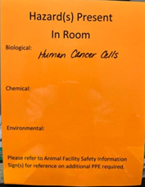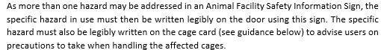

    - Before dosing, the appropriate hazard sticker (biological, chemical, radiologic, and/or environmental) is to be placed on the cage card along with the name of the hazard and the date the material is dosed or present. A blue acetate should also be labeled with the appropriate hazard symbol, name of the hazard, and when the hazard was dosed. Once the hazard is cleared from the waste and bedding, the hazard sticker is to be covered with a white sticker and the labeled blue acetate removed if appropriate.

Biological Hazard Cage Labeling

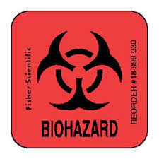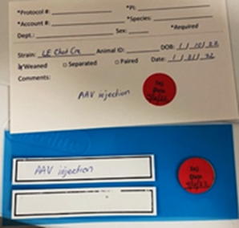

Chemical Hazards Cage Labelling

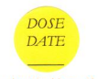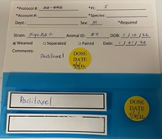

Environmental Hazards

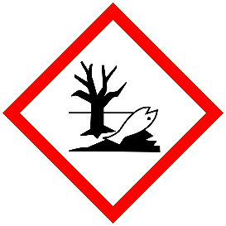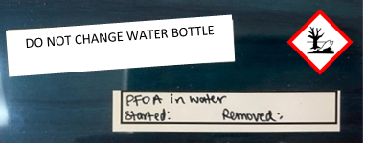

Radiological Hazard Cage Labelling

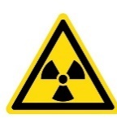

    - If changing cages in the housing room, have the appropriate cage with feeder lid, water bottle, feed, bedding and Enviro-dry prepared before the animal transfer. Transfer animals to the new clean cage. Place the dirty hazard cage in the housing room where indicated, label the cage with a card that says biological, chemical, radiologic, and/or environmental hazard and mark the specific hazard on the card. Leave the cage in the housing room for LAR staff to pick up and take to the cage wash to be cleaned.

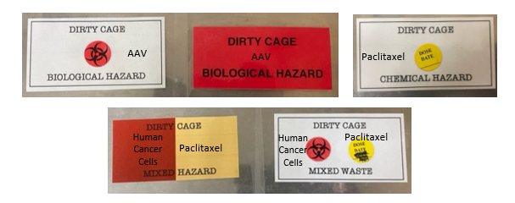
Dirty hazard cages are left fully assembled in the designated area within the animal room, on the designated dirty cage holding rack, or in the designated area within the dirty washroom. A laminated hazard designation card is placed on the cage, and the specific name of the hazard is placed on the laminated label with a Sharpie pen. Once the dirty cage is processed in cage wash, the label is cleaned with ethanol, removing the hazard name and the dirty cage label so it may be used again. If you are unsure as to the location of hazard stickers, laminated dirty hazard cage cards, or where to place dirty hazard cages, please ask your LAR Animal Care Staff before starting work or leaving dirty items.

References

- Public Health Service Policy on Humane Care and Use of Laboratory Animals, published by the Office of Lab Animal Welfare, NIH.
- Occupational Health and Safety in the Care and Use of Research Animals, published by the National Academy of Sciences, 1997.
- Guide for the Care and Use of Laboratory Animals, published by National Research Council
- Biosafety in Microbiological and Biomedical Laboratories 6th Edition, published by the Centers for Disease Control and Prevention and the National Institutes for Health.
- NIH Guidelines for Research Involving Recombinant or Synthetic Nucleic Acid Molecules (NIH Guidelines)
- Federal Select Agent Regulations (7CFR331, 9CFR121, and 42CRF73)
- Indiana University Laboratory Safety and Chemical Hygiene Plan https://protect.iu.edu/doc/environmental-health/IU_Laboratory_Safety_and_Chemical_Hygiene_Plan.pdf
- Code of Federal Regulations, PART 20—Standards For Protection Against Radiation Title 10, Part 20

Appendix 1
Appendix 2
